Victor Ngetich

CS 305

6/12/25

Report before suppression

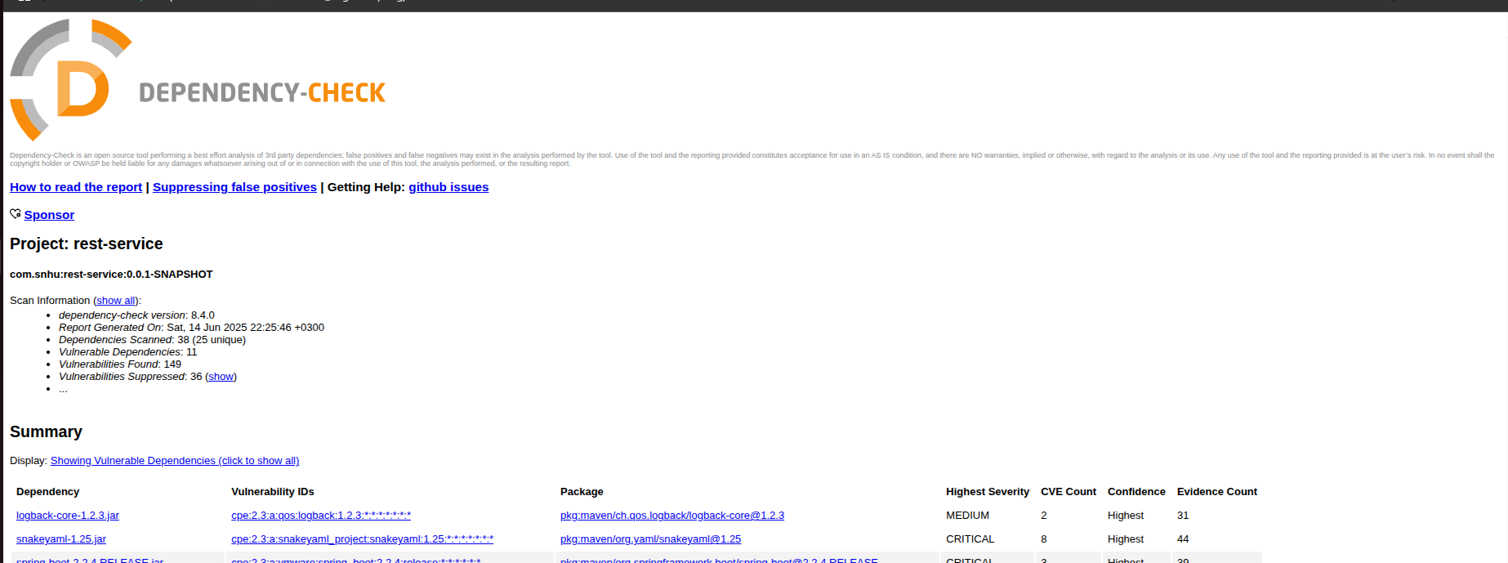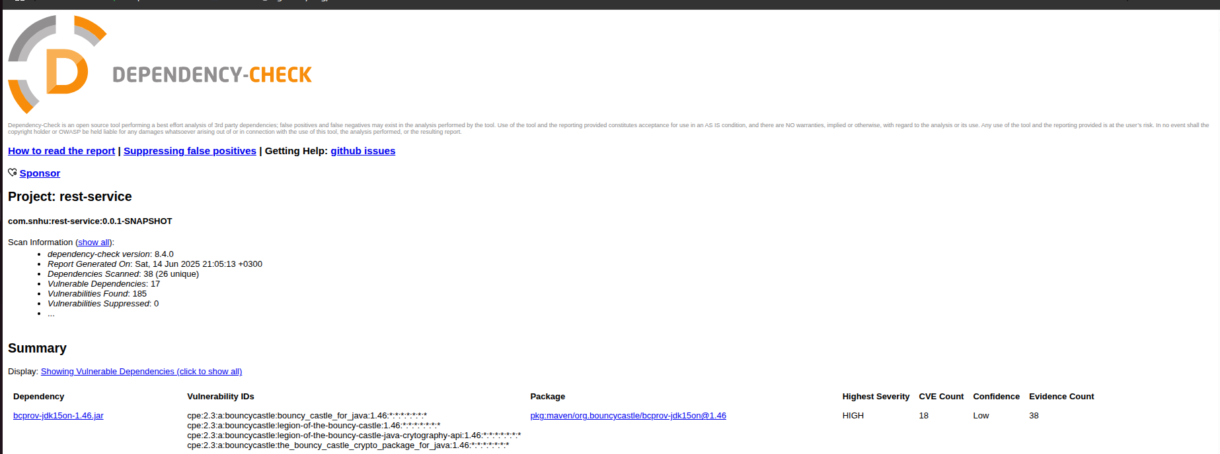

Report after suppression